Firefox https://moodle.fer.hr/mod/quiz/review.php?attempt=640057&cmid=1293

Moja naslovnica / Moji e-kolegiji / tuum / Opći dio / Kviz iz laboratorijskih vježbi 1 i 2 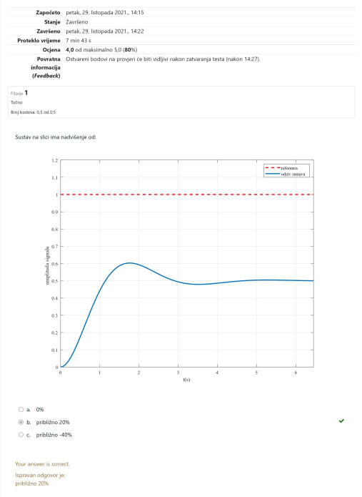1 of 7 31/10/2021, 11:2

Firefox https://moodle.fer.hr/mod/quiz/review.php?attempt=640057&cmid=1293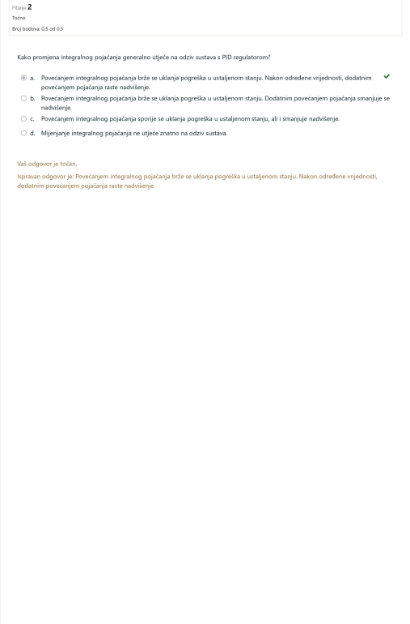2 of 7 31/10/2021, 11:2

Firefox https://moodle.fer.hr/mod/quiz/review.php?attempt=640057&cmid=1293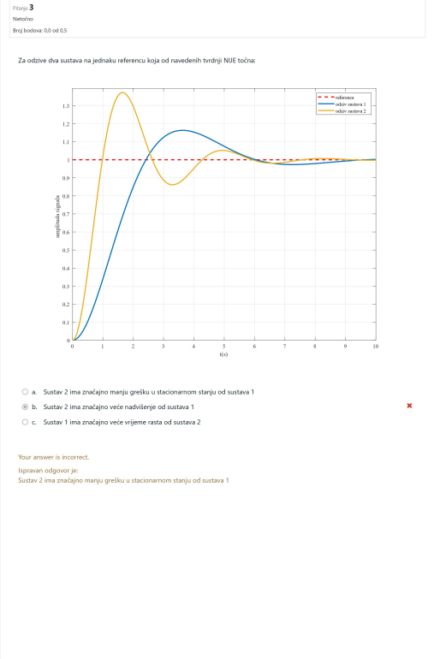3 of 7 31/10/2021, 11:2

Firefox https://moodle.fer.hr/mod/quiz/review.php?attempt=640057&cmid=1293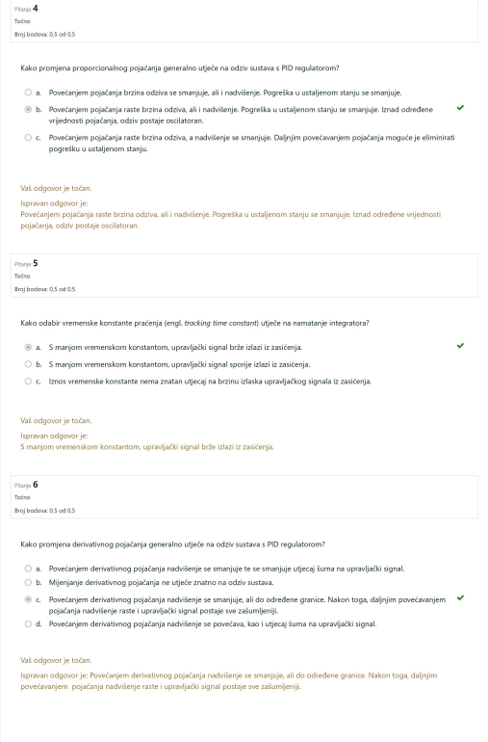4 of 7 31/10/2021, 11:2

Firefox https://moodle.fer.hr/mod/quiz/review.php?attempt=640057&cmid=1293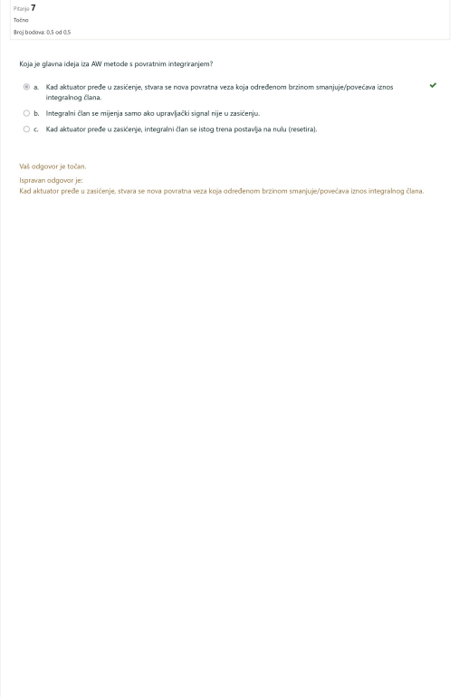5 of 7 31/10/2021, 11:2

Firefox https://moodle.fer.hr/mod/quiz/review.php?attempt=640057&cmid=1293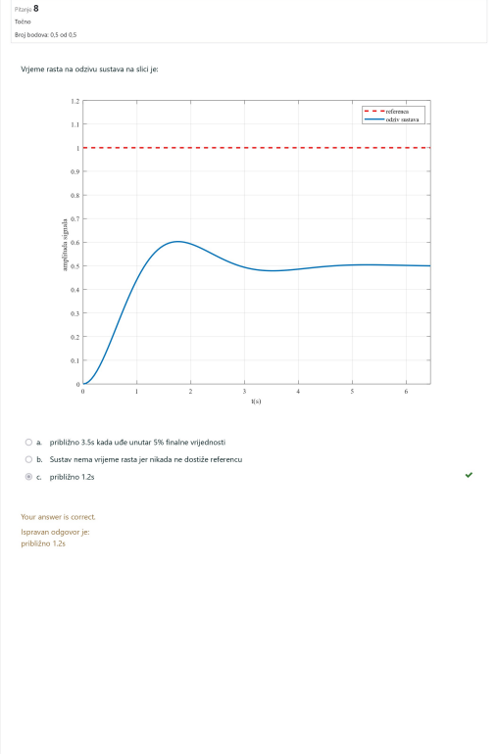6 of 7 31/10/2021, 11:2

Firefox https://moodle.fer.hr/mod/quiz/review.php?attempt=640057&cmid=1293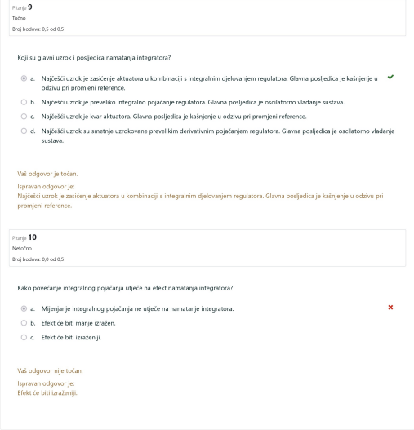

7 of 7 31/10/2021, 11:2